**The Antipodeans Group**

*The Antipodeans* was the title of a group exhibition of figurative painters at the Victorian Artists' Society in August 1959. Signatories to the exhibition catalogue (the notorious *Antipodean Manifesto)* were the Melbourne artists Charles Blackman (b. 1928), Arthur Boyd (1920 – 1999), David Boyd (1924-2011), John Brack (1920-1999), Bob Dickerson (b.1924, a Sydney artist), John Perceval (1923-2000) and Clifton Pugh (1924-1990). The influential art historian and critic Bernard Smith (1916-2011) was the *Manifesto*’s author and co-signatory. Many had been active members of the radical Melbourne Branch of the Contemporary Art Society through the war years, and were associated with other figurative artists such as Sidney Nolan (1917-1992) Albert Tucker (1914-1999) and Russell Drysdale (1912-1981). *The Antipodeans* was a tactical intervention into post-war cultural debate, railing against the perceived uncritical following of European and US models of abstraction and the superficial gestures of neo-Dadaist play. In contrast, the *Manifesto* held that the artist should create significant images and narratives for a “young country yet to make its own myths”. In this, the group was firmly committed to the modern figurative image: “[T]he image, the recognisable shape, the meaningful symbol, is the basic unit of [the artist's] language... It is born of past experience and refers back to past experience — and it communicates. It communicates because it has the capacity to refer to experiences that the artist shares with his audience.”

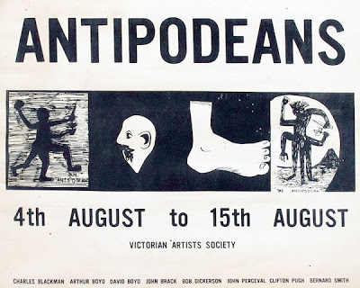

Charles Blackman, Poster for *The Antipodeans* Exhibition, Victorian Artists Society, Melbourne, August 1959 (<http://artsearch.nga.gov.au/Detail.cfm?IRN=104454>)

The Antipodeans’ call to arms challenged and also reflected the cultural chill of the Cold War. Artists on the Left saw Australian politics and culture under the long-standing Liberal Party government of Robert Menzies as conservative, conformist, and racist. Assimilation policies towards Indigenous Australians had disenfranchised the country’s greatest artists, the Aborigines. The White Australia Policy kept everybody but British and European migrants out, and xenophobic and anti-communist fears of an imaginary “Yellow Peril” in China had resulted in Australia’s participation in the Korean War. The fear of nuclear war was ever-present and unspecified.

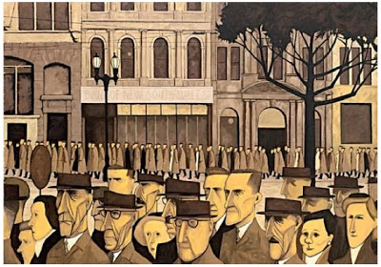

John Brack, *Collins St, 5p.m.,* 1955, oil on canvas, 114.6 x 162.9 cm.

(Source: <http://www.ngv.vic.gov.au/johnbrack/education/imagebank.html> )

In creating progressive and humanist ‘myths for a new Australia’, the Antipodean artists borrowed from European surrealist and neo-romantic ideas. They drew upon subjective, often unconscious imagery and themes, which were projected outward onto the unique Australian environment. Many of the exhibited artworks articulate the alienation of modern urban life and the difficulties of reconnecting the artist with society and culture, or the thwarted desire for spiritual connection with place (eg. John Brack, *Collins St, 5p.m.,* 1955). This failed search for connection is often exemplified through individual artistic gestures of rapproachment with the Australian Aborigines, the landscape, and by extension, a mythic Australian past. Paintings show the human and natural world as intersecting and dynamic forces. Spate observes how recurrent motifs also endowed the post-war Australian landscape with this renewed mythic grandeur. For many figurative artists in this period, the landscape became a vehicle for expressing crucial relationships: between people, between the individual and the group, and between people and their environment (in Australia, the relation between the city and ‘the bush’ has been a long-standing, colonial preoccupation).

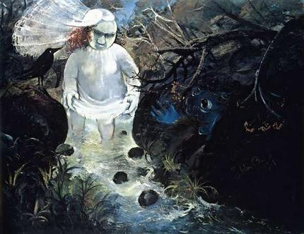

Arthur Boyd, *Bride Walking in a Creek I*, 1959. Oil and tempera on composition board, 105.5 x 136.5 cm. Exhibited *The Antipodeans*, Victorian Artists' Society Galleries, Melbourne, 4 - 15 August 1959, cat. 13 ([www.artrecord.com](http://www.artrecord.com))

Common figures in the post-war landscape included the hero (or rather, anti-hero), as in Nolan’s *Bourke and Wills* canvases and his extended *Ned Kelly* series, or in Tucker’s elaborations on the related themes of explorers in his ‘Antipodean Heads’, all of which merge Romantic myths about the artist as outsider with colonial myths of exploration. Another recurrent figure is the child, found in Blackman’s *Schoolgirls* series, or Pugh’s *The World and Shane and Dailan* (1957), which renew a popular late Victorian and Edwardian motif of the Australian child ‘lost in the bush’, where the child inhabits another world, or is seen to be closer to nature and to an ‘Aboriginalised’ Australian bush. A third common motif is that of doomed lovers, which may be cast within a cross-cultural scenario: the Antipodean depiction of Aborigines, as found in David Boyd’s *Truganini - a dream of childhood* (1958-59) and Arthur Boyd’s series *Love and Death of a Half-caste* (1959), was a radical challenge to mainstream Australia during the assimilationist era. Spate notes how these relationships are often characterised by a sense of alienation at their heart, and interprets this perceived alienation as a quintessentially Australian awareness of the colonial and convict legacies. At the same time, the theme of alienation was understood in the post-war international art context as embodying universal or essential human values (as in the ’human condition’ after the Holocaust and Hiroshima). In this, the figurative paintings of the Antipodeans group actually share universal, literary and ahistorical references with those by contemporary abstract artists whom they so vehemently opposed.

**References and further reading**

*The Antipodeans: Challenge and Response in Australian Art 1955-1965*, (1999) Canberra: National Gallery of Australia. (A comprehensive and well-researched exhibition catalogue referencing the informed opinions and recollections of contemporary writers).

Dixon, C. and Smith, T. (1984) *Aspects of Australian Figurative Painting 1942-1962: Dreams, Fears and Desires*, Sydney: Power Institute of Fine Arts. (Virginia Spate’s excellent essay in this scholarly exhibition catalogue offers perceptive thematic insights to the Antipodean’s Cold War mindset and imagery).

Smith, B. (1959) ‘The Antipodean Manifesto’, reprinted in Bernard Smith, *The Death of the Artist as Hero: Essays in History and Culture, OUP, 1988* (The *Manifesto* outlines the objectives of the Antipodean group. This and other essays in this collection, written by Antipodean participant Bernard Smith, give a good sense of the partisan cultural politics of the postwar period).

Smith, B. (with Smith, T). (2001) ‘Figurative and Non-Figurative 1950-60’, in *Australian Painting 1788-2000*, Melbourne: Oxford University Press (This chapter in the still-useful survey of Australian art articulates the key debates around figuration and abstraction in the period and discusses the Antipodean artists in the context of work by their Australian peers.)